Atilla Genc

Homework 1

1. Install Virtualbox
2. Install Centos 7
3. Create user as your first letter in the first name and last name
4. Ex: Kranthi kavuri = kkavuri
5. Go to your home directory
6. Create subdirectories in your home directory with your username + 1 & 2
7. Create a file with your username
8. Change the permissions for the file to read and write but not execute
9. Change the permissions for the file to read and execute but not write
10. Write two lines in a file and display it to the screen
11. Install Virtualbox
12. Install Centos 7

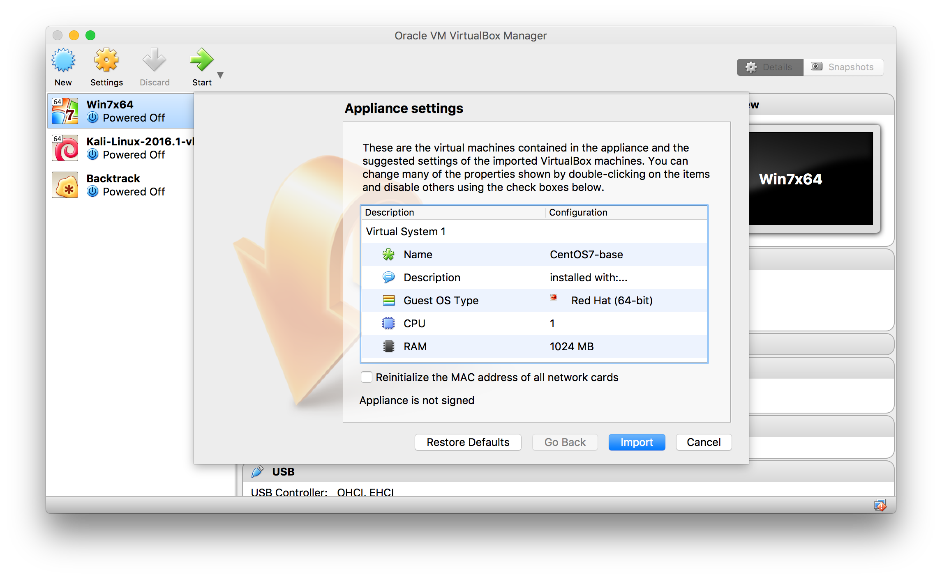

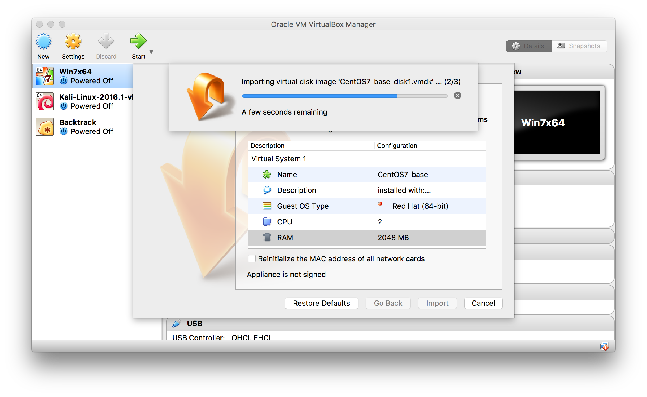

1. Create user as your first letter in the first name and last name

Ex: Kranthi kavuri = kkavuri

Username = agenc

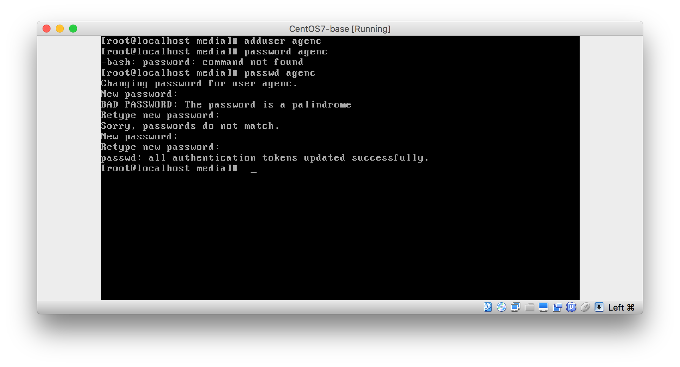

1. Go to your home directory

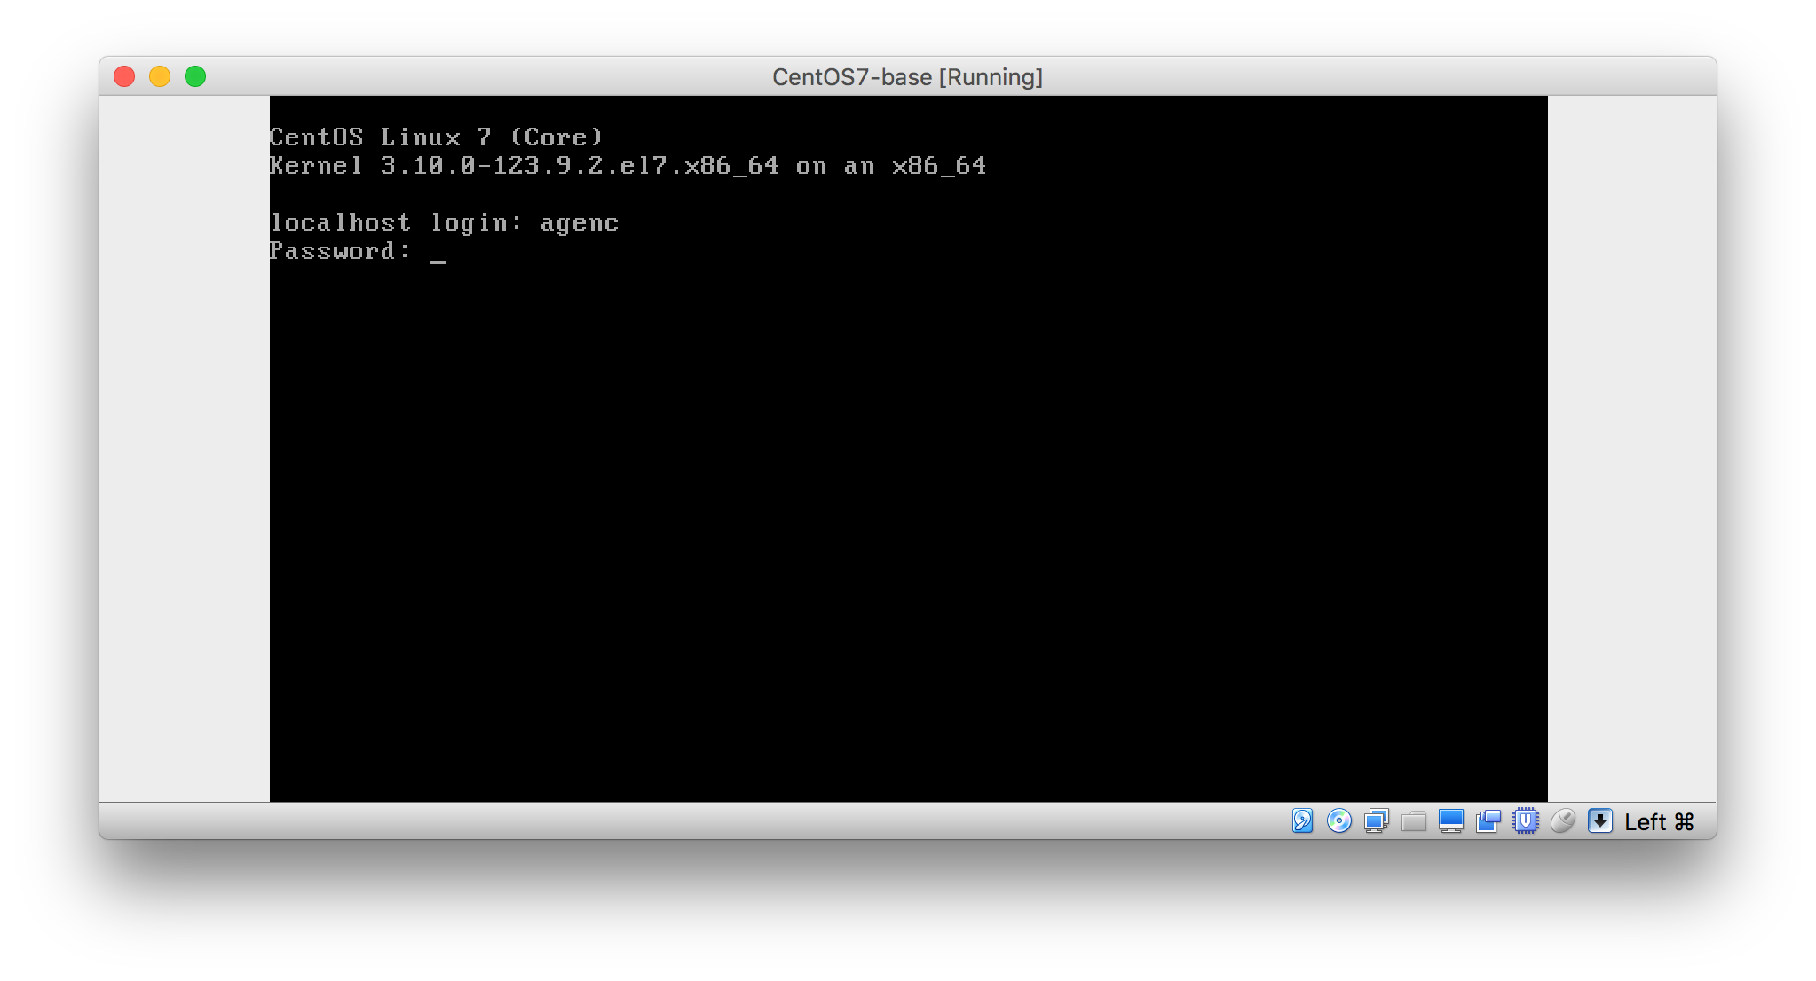

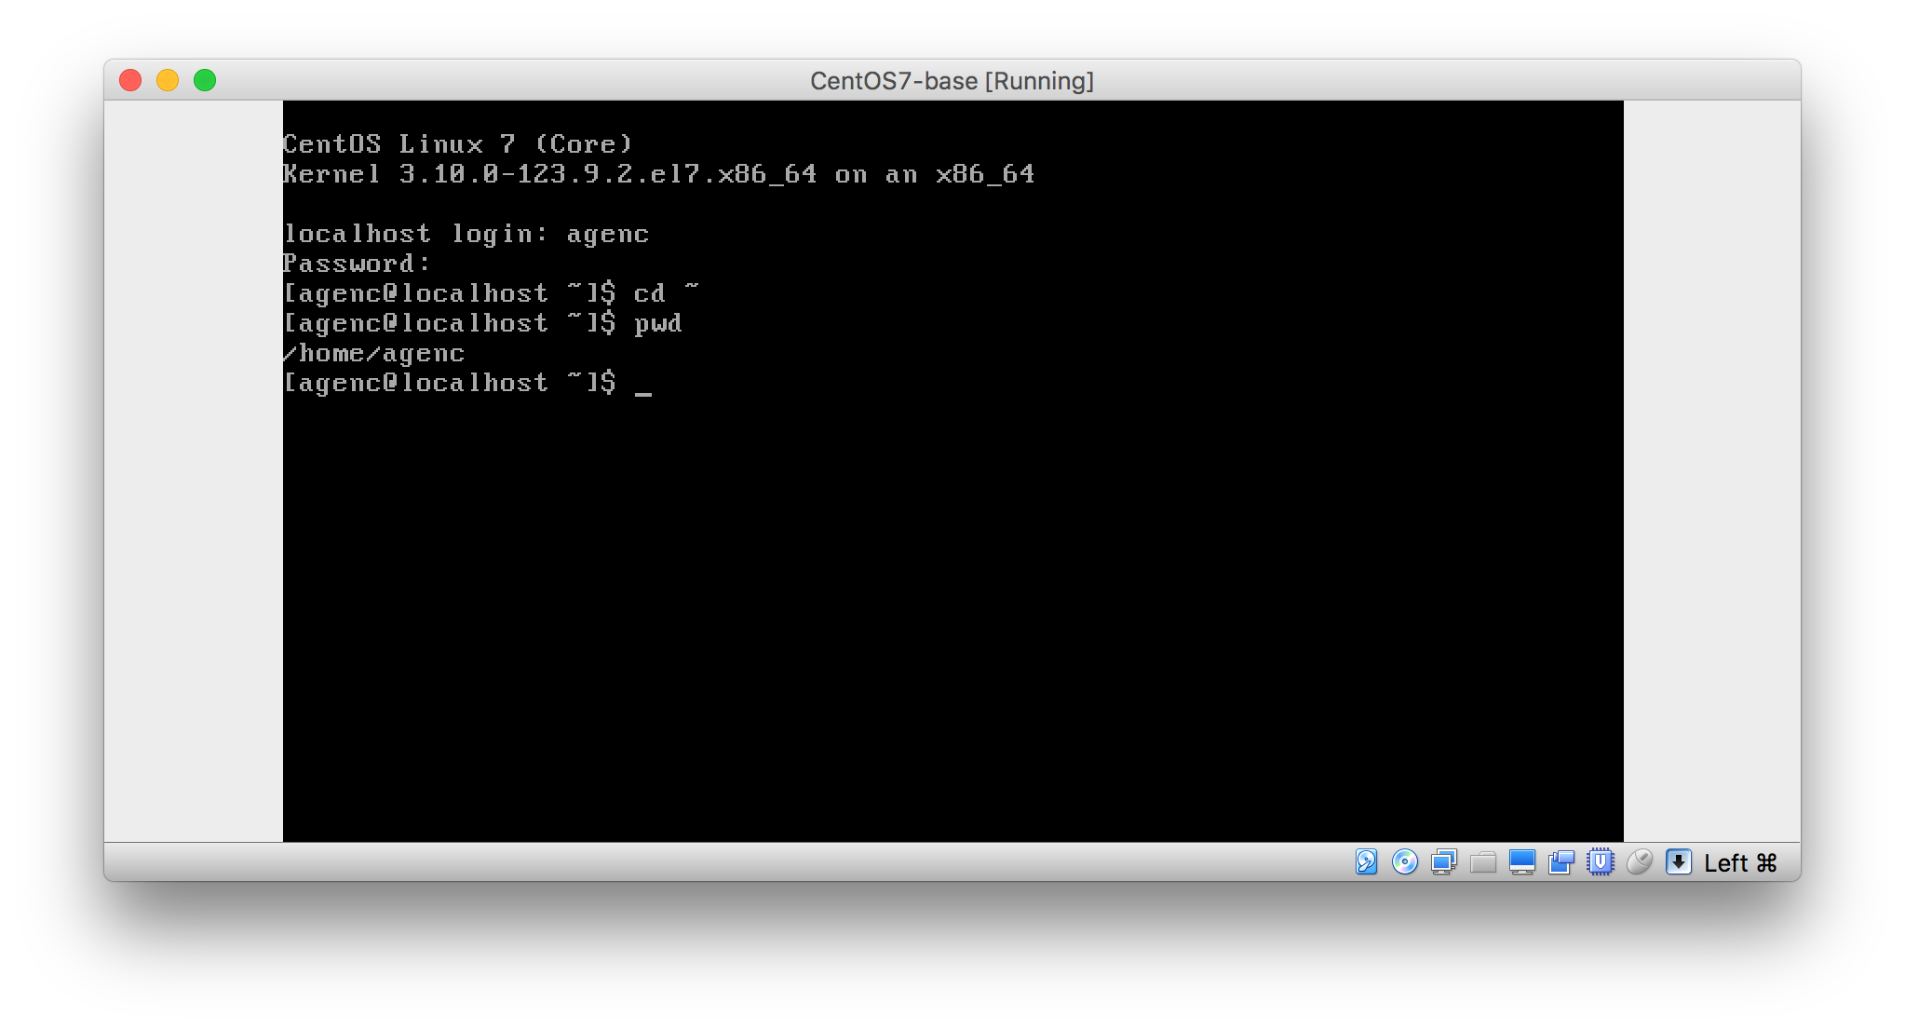

1. Create subdirectories in your home directory with your username + 1 & 2

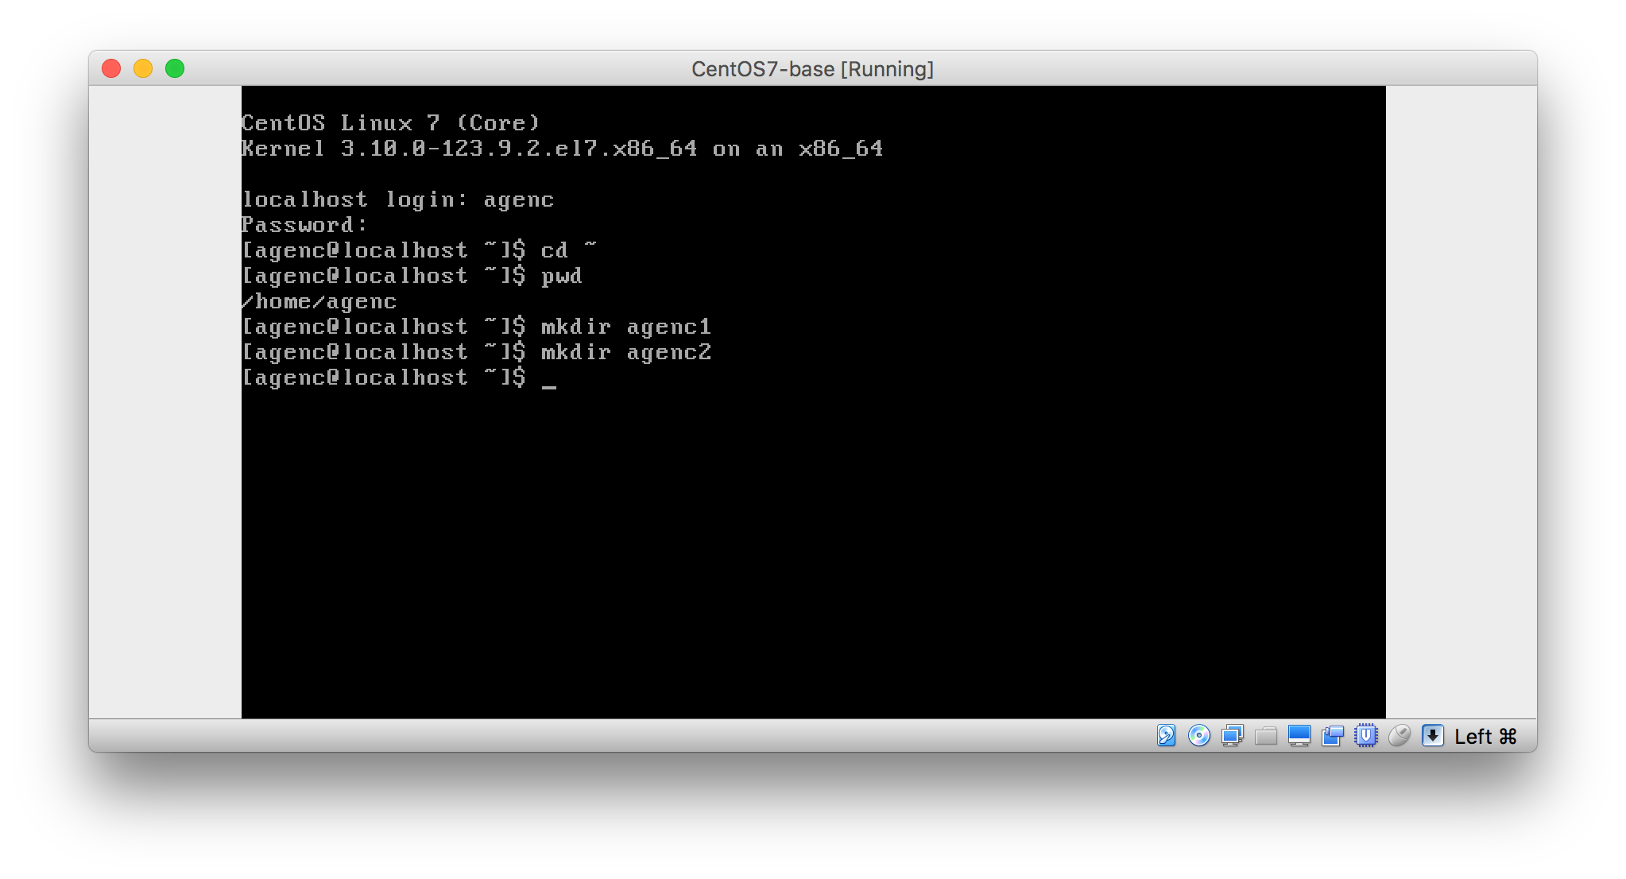

1. Create a file with your username

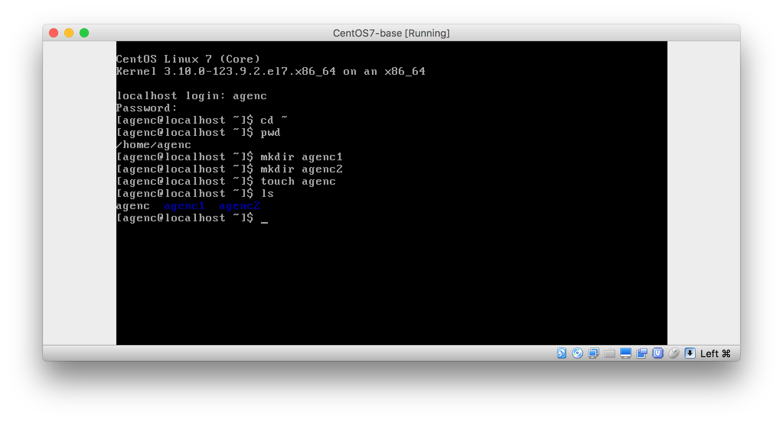

1. Change the permissions for the file to read and write but not execute

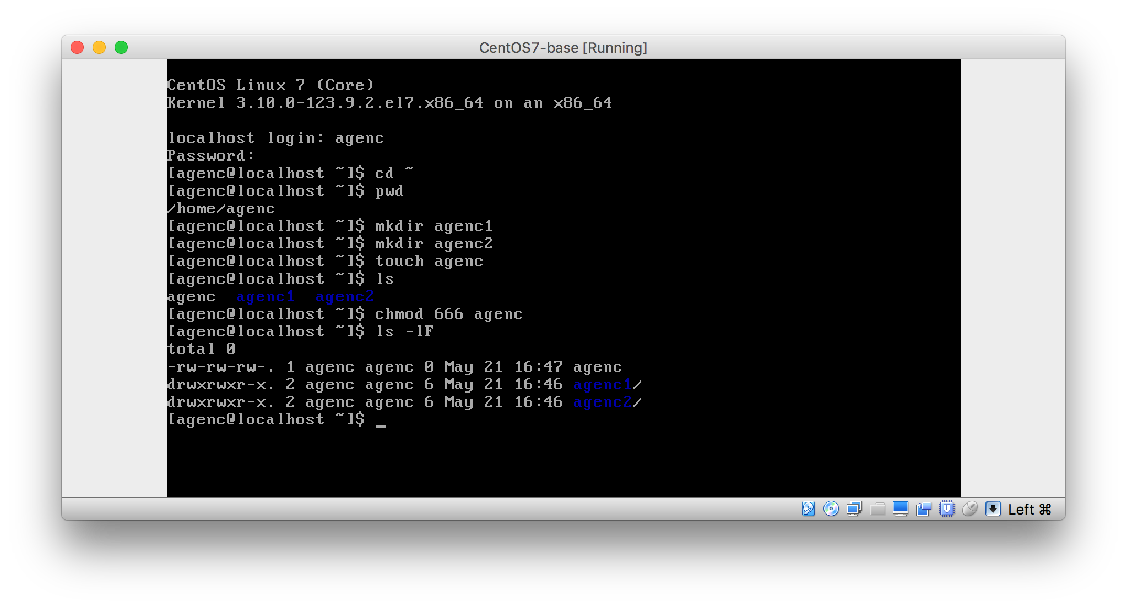

1. Change the permissions for the file to read and execute but not write

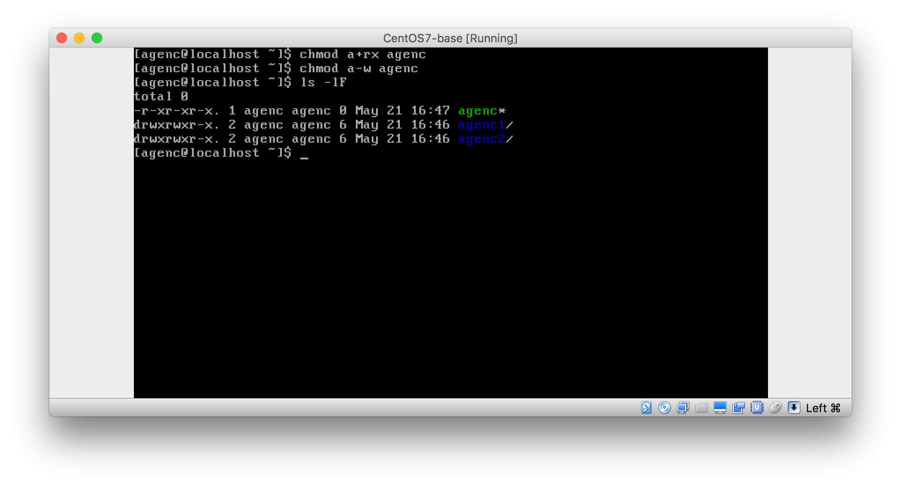

1. Write two lines in a file and display it to the screen

